**CENWP-OD-B 13 July 2024**

**MEMORANDUM FOR THE RECORD**

**SUBJECT: 24BON027 MFR CI LPS RB3 Pacific Lamprey Mortality**

On the morning of 13 July 2024, Project Biologists discovered one Pacific Lamprey mortality in Rest Box 3 of the Cascades Island LPS (CI LPS RB3). The fish was inspected, measured, scanned for PIT tags, and returned to the river.

1. Species – Pacific Lamprey (*Entosphenus tridentatus*)
2. Origin – Unknown
3. Length – 63.5cm
4. Marks and tags – None
5. Marks and Injuries found on carcass – None, some abrasion around the gill holes on the dorsal side
6. Cause and Time of Death –Unknown
7. Future and Preventative Measures – N/A

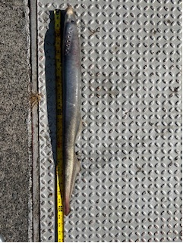

Sincerely,

Project Fisheries